Getting ready to go

Workbook 2

My money

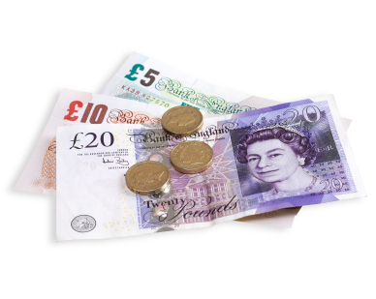

English to help you get ready if you are going to live the UK after release

Unit 2 My Money

Contents page

How to use the workbook 3

Task 1 Money words 5
Important words you need

Task 2 Quizzes and puzzles 8
Fun activities

Task 3 Taking care of your money 10

Task 4 Shopping for food 14

End of unit check 16

Answers 17

How to use the workbook

This workbook has activities on;

- reading
- vocabulary
- grammar
- writing

You need a pen or pencil.

Read the instructions for each task carefully.

Do the activities then check your answer using the ANSWERS pages at the back of the workbook.

Unit 2 – Looking after your money
Learning goals
At the end of this section you will be able to:
- use words about money and looking after your money
- read information to help you look after your money when you leave prison
- read about choosing things you want or need
- write and use vocabulary about shopping and buying food.

Task 1 Money verbs
(1)
Here are some verbs (doing words) we use to talk about money. Can you write them in the space next to their meanings? You can use a dictionary or ask a friend for help.
buy borrow lend pay save spend

verb | meaning
keep money to use in the future
(help: I _________ to buy something expensive like a TV)
get something from the shop by paying money for it
(help: I can _________ a pizza to eat)
give money to a friend for a short time
(help: I will __________ Amina £10 as she has no money)
give money to someone to buy something
(help: I ___________ the shopkeeper for my sweets)
use your money to buy things
(help: I __________ lots of money at the supermarket)
get money from a friend for a short time
help: (I can _________ £5 from Jan as she has lots of money)

(2) Now it’s time to practise these verbs. Use the verbs to fill the gaps.

buy borrow lend pay save spend

- Can I ……………… five pounds until Saturday? Then I will pay you back.

- How much money did you ……………… at the shop?

- I can ……………… money to buy a car, if I put a little bit in the bank each week..

- Can you ……………… me ten pounds until Friday? I haven’t any money to go out.

- I would like to ……………… a new coat for the winter.

- I ……………… for my lunch at the cafe with the coins I have in my pocket.

Check your answers at the back. How well did you do?

(3) Money words
Draw a line to match the words and pictures.
gift voucher
coins

five pound note

meal voucher

bank card
cheque book

‘Get on in the community Module 1: Financial skills and budgeting’ © Learning and Skills Improvement Service http://rwp.excellencegateway.org.uk/Embedded%20Learning/Community/Get%20on%20in%20the%20community/
(4) You and your money – write some words on the lines in the boxes
These are__coins_____________
I can use them to buy sweets at
___________________________

This is a _____________________
I can get one from ____________________________

This is a _____________________
I can use this to buy ____________________________

This is a _____________________
I can use this to buy
_____________________________

This is a ______________________
I can use this to buy
_____________________________

This is a ______________________
I can get one from
______________________________

Task 2 Quizzes and puzzles
(1) This is fun!
Read the quiz questions. Tick the one you’d do.
- You have a lot of coins in your pocket. Do you:
- save them in a money box or coin jar?

- buy some sweets?
- throw them away?

- When you get your money for the week. Do you:
- spend what you need and save some?
- spend it all before the weekend?
- spend it very quickly in two days?

- You run short of money. Do you:
- offer to do some jobs to earn extra money?
- do without money ?
- borrow from friends or family?

- You find £20 on the floor. Do you:
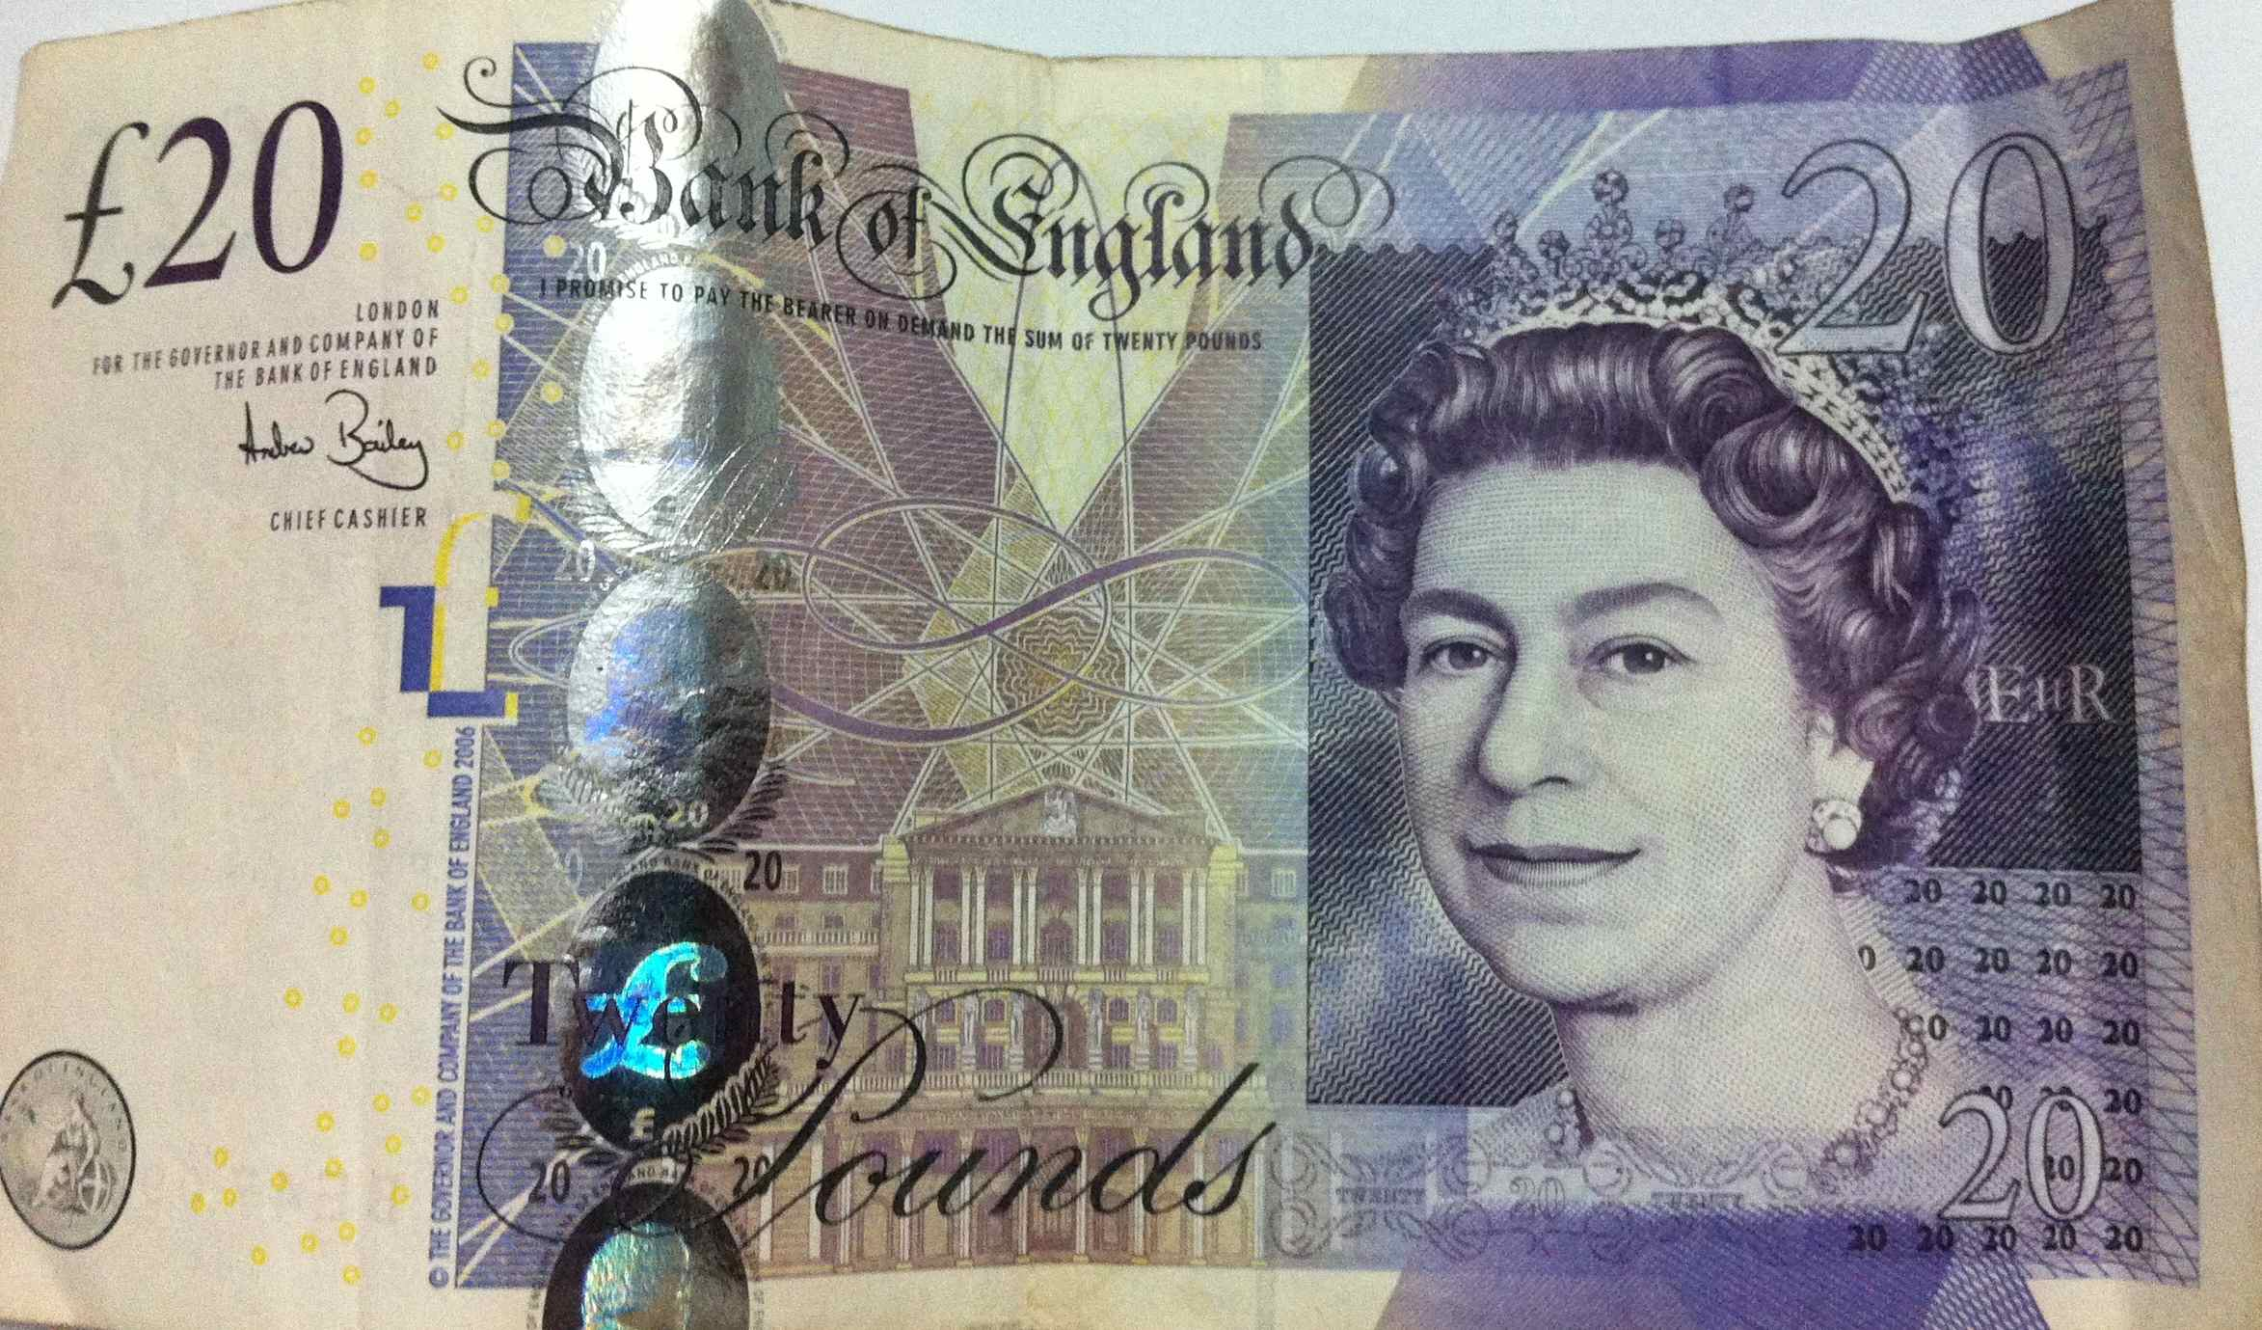
- ask if anyone has lost it?
- give it to charity?
- give it to a friend?

- You buy a present for a friend. Do you:

- find something small they’d like?
- spend a little bit and buy yourself something?
- use all your money for a big present?
Add up your marks.
- = five marks b.= three marks c.= one mark
How many marks did you get?
20 – 25 = excellent 15 – 20 = you think about money 10 -15 = think carefully about your money

(2) Word search
Can you find all the words about money?
Draw a circle around the words. Read from top to bottom or left to right.

Find these words in the puzzle

buy borrow save lend spend coins
cheque bank card notes pay

b | c | n | d | p | r | u | d | u | n
a | b | o | r | r | o | w | w | f | d
e | u | t | b | h | g | b | r | r | m
f | y | e | n | p | c | o | i | n | s
v | t | s | s | a | r | u | g | h | n
m | l | j | d | y | e | l | e | n | d
c | h | e | q | u | e | e | g | j | s
c | o | i | h | g | d | n | o | t | d
b | d | e | s | p | e | n | d | f | j
a | b | b | a | n | k | c | a | r | d

Task 3 Taking care of your money
The money you have to live on can come from different places. It can be from work you do or benefits the government give you.

- Will you have a job when you come out of prison? Will you get benefits?
- Will you have lots of money? Will you get help from family and friends?
- Write some words in the box about where you will get money.

(1)
I will get money from……

You will need some things to live. You could not live without some things, for example, food.
You may want some things. You could live without them, for example, a new car.

A need is something you can’t live without.
A want is something you can live without.

(2) What do you need? What do you want? Circle want or need.

- a house? Want / need?

- a car? Want / need?

- food? Want / need?

- a mobile phone? Want / need?

- water? Want / need?

- a new coat? Want / need?

(3) Taking care of your money game

Instructions

- Cut or tear the cards from the next two pages and use them for a game.
- Mix the cards up.
- Put the cards face down and choose 6.
- Turn over the cards and decide which ones make you money and which ones lose you money?

Can you add up how much you have made? Can you add up how much you’ve lost?

Try it again!
Practise adding up and subtracting (taking away)

Find a friend to play this with as a game and take turns. The winner is the person with the most money at the end.

Play it again with 10 cards

Adapted from ‘Get on in the community Module 1: Financial skills and budgeting’ © Learning and Skills Improvement Service http://rwp.excellencegateway.org.uk/Embedded%20Learning/Community/Get%20on%20in%20the%20community/

you find £2 in the street | you pay £30 for petrol
it’s your birthday and you get £25 | you have a hole in your pocket and lose £3
you borrow £20 from a friend, you must pay it back | you win £10 on the lottery
you buy some jeans for £42 | you sell some things and get £60
you get £230 for working | you get a voucher for £5 off your shopping
you pay £22 for food with your bank card | you get £25 for helping a friend
Write your own here | Write your own here

you spend £10 to top up your phone | you buy a breakfast for £3
you buy a pizza and a bottle of wine for £10 | you buy a £7 travel card for the bus
you make a meal with a tin of tuna and a baked potato and two tomatoes for £1 | you buy milk, cereal and bread for £3.50
you lend your friend £10 | you buy a t-shirt for £4
buy 5 apples for 50p at the market | buy a birthday present for £6
Write your own here | Write your own here
Write your own here | Write your own here

Task 4 Shopping for food.
Cheap = if something costs only a little money, it is cheap.
Expensive = if something costs a lot of money, it is expensive.

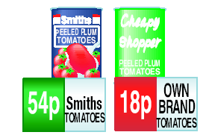
expensive = more money cheap = less money

Words you will need:
cheap = little money
expensive = lots of money
special offer = something is cheap for a short time
buy one get one free = you get two things for the price of one
2 for 1 two for one) = get two things for the same price as one
3 for 2 (three for two) = get three things for the price of two
a bargain = a very cheap thing
reduced = for sale at a cheap price
Have a look at the pictures on the next page and answer the questions.
- How much is the cheaper tin of beans?......................................................
- How much is the more expensive chicken? ..............................................
- What is the special offer on bread? ...........................................................
- What food has a buy one get one free offer? ...........................................
- How much is the cheaper pizza? ...............................................................
- What is the special offer on oranges? ......................................................
Check your answers at the back of the workbook.
Shopping

End of unit check
Well done. You have finished this section of the work book.
How do you feel? Tick () the box that is true for you.

 | Yes | A little | No
I feel my reading is better.
I can use verbs to talk about money.
I feel I can understand words for shopping
I can compare prices
I know lots of new words.

Have you checked your answers?

Answers

Task 1
(1)
borrow get money from a friend for a short time
buy get something from the shop by paying money for it
pay give money to the shop keeper to buy something
save keep money to use in the future
lend dive money to a friend to use for a short time
spend use money to buy something
----------------------------------------------------------------------------------------------------
(2)
- Can I borrow five pounds until Saturday? Then I will pay you back
- How much money did you spend at the shop?
- I can save money to buy a car, if I put some in the bank each week.
- Can you lend me ten pounds until Friday? I haven’t any money to go out.
- I would like to buy a new dress for the party.
- I pay for my lunch with the coins I have in my pocket.
------------------------------------------------------------------------------------------------------------------

(3) Money words
Draw a line to match the words and pictures.

gift voucher

coins

five pound note

meal voucher

bank card
cheque book

Task 2 Quizzes and puzzles
(2)
b | c | n | d | p | r | u | d | u | n
a | b | o | r | r | o | w | w | f | d
e | u | t | b | h | g | b | r | r | m
f | y | e | n | p | c | o | i | n | s
v | t | s | s | a | r | u | g | h | n
m | l | j | d | y | e | l | e | n | d
c | h | e | q | u | e | e | g | j | s
c | o | i | h | g | d | n | o | t | d
b | d | e | s | p | e | n | d | f | j
a | b | b | a | n | k | c | a | r | d

Task 3
(2) What do you need? What do you want?

- a house? need
- a car? want
- food? need
- a mobile phone? want
- water? need
- a new coat? want (It’s a want if you have one. It’s a need if it’s cold and you don’t have a coat.)
--------------------------------------------------------------------------------------------------------------------------------
Task 4
1.How much is the cheaper tin of beans? 15p
2.How much is the more expensive chicken? £4
3.What is the special offer on bread? 2 for 80p
4.What food has a buy one get one free offer? pasta
5.How much is the cheaper pizza? £2
6.What is the special offer on oranges? 4 for 30p

‘Get on in the community Module 1: Financial skills and budgeting’ © Learning and Skills Improvement Service http://rwp.excellencegateway.org.uk/Embedded%20Learning/Community/Get%20on%20in%20the%20community/

